Project Initialization and Planning Phase

Date | 03-07-2026
Team ID
Project Name | Smart Agricultural Preduction Optimization Engine
Maximum Marks | 3 Marks

Define Problem Statements (Customer Problem Statement Template):



Create a problem statement to understand your customer's point of view. The Customer Problem Statement template helps you focus on what matters to create experiences people will love. A well-articulated customer problem statement allows you and your team to find the ideal solution for your customers' challenges. Throughout the process, you’ll also be able to empathize with your customers, which helps you better understand how they perceive your product or service.

Example:
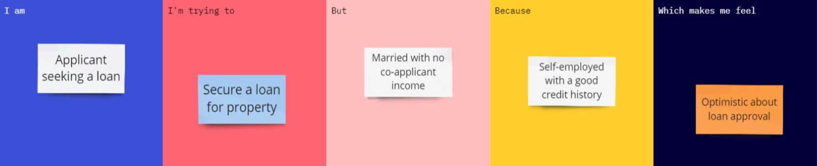

Problem  Statement  (PS) | I am (Customer) | I’m trying  to | But | Because | Which makes me feel
PS-1 | A small-scale farmer with 2-3 acres of land | Select the most profitable crop for my soil | I don't know my soil's N,P,K values and weather suitability | Soil testing labs are far away and expensive | Helpless and worried about crop failure

